Measurement Protocol PAX

# General Information:

|  |  |  |
| --- | --- | --- |
| Test date: 15/01/20 | Date prev. test: | Test number: 1 |
| Tested by: Jaz Hill-Valler | PAX number: PB-006 | Installed at ant.: 2H |
| Comments: Slightly “bumpier” passband towards the end of passband | | |
|  | | |
|  | | |
|  | | |
| Known problems: | | |
|  | | |
|  | | |
|  | | |

# Setup:

|  |  |  |  |
| --- | --- | --- | --- |
| Power supply: | OK 🗹 NOK 🗆 | Communication: | OK 🗹 NOK 🗆 |
| Supply current +6V: 1.093A | | ssh obs@antcntl | |
| Supply current -6V: 0.117A | | ssh ataant@paxtester | pw: q@n@t |
| Supply current +5V: 0.116A | | telnet pax | “help” |
|  | | CTRL + ] | “close” |

# RF Test with VNA:

### VNA Setup:

|  |  |  |
| --- | --- | --- |
| Load configuration: Passband_PAX.csa | | |
| Freq Start: 1.0 GHz | Freq Stop: 13.0 GHz | Power Level: -20 dBm |
| Averaging: enabled | Averaging count: 15 | N. Points: 801 |
| VNA : Agilent N5230C 10MHz - 20GHz | | |

|  |  |  |  |  |
| --- | --- | --- | --- | --- |
| VNA to PAX connection: | 1m ABC-CA18 Cable + 20dB Attenuator | | | |
| Input Power Level to PAX: (Measured) | @1GHz:  -40.2dBm | @4GHz:  -40.7dBm | @8GHz: -41.2dBm | @12GHz: -41.4dBm |

|  |  |
| --- | --- |
| PAX to VNA connection: | 2m Fibre Cable + Fibre Diode + AOX Amplifier + 1m ABC-CA18 Cable |

### Measured Passband with Attenuator set to 7dB each (Complete Link):

|  |
| --- |
| X |

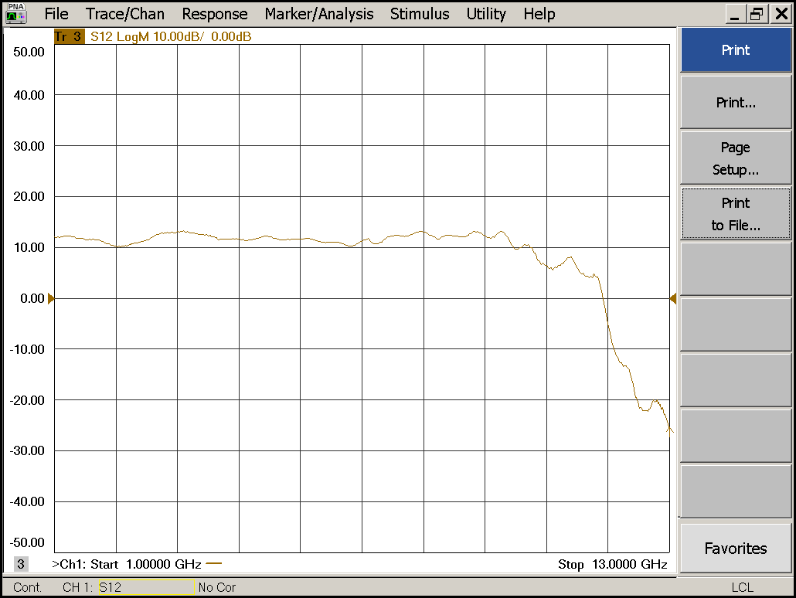

|  |  |  |  |
| --- | --- | --- | --- |
| Flatness: | OK 🗹 NOK 🗆 | Unwanted Features: | Yes 🗆 No 🗹 |

|  |
| --- |
| Y |

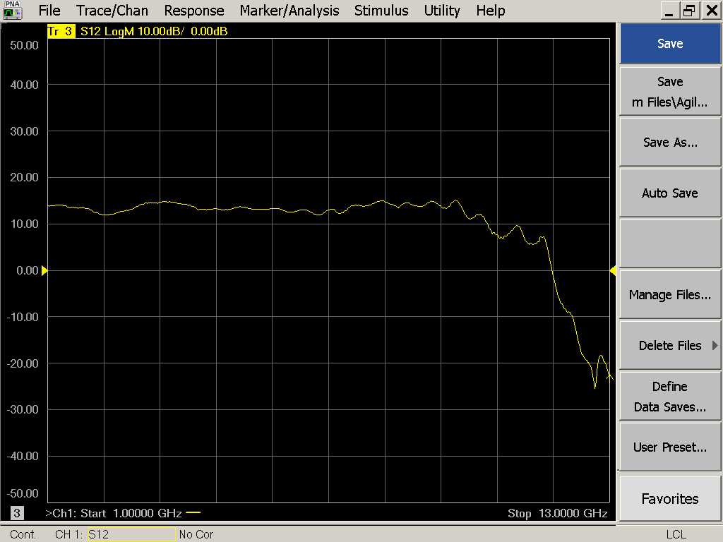

|  |  |  |  |
| --- | --- | --- | --- |
| Flatness: | OK 🗹 NOK 🗆 | Unwanted Features: | Yes 🗆 No 🗹 |

### Power Sweep (Complete Link):

|  |  |  |
| --- | --- | --- |
| Load configuration: Power_Sweep_PAX.csa | | |
| Power Start: -40dBm | Power Stop: -20dBm | Frequency : 4.0GHz |
| PAM Attenuator: 0dB |  | N. Points: 801 |

|  |
| --- |
| X |

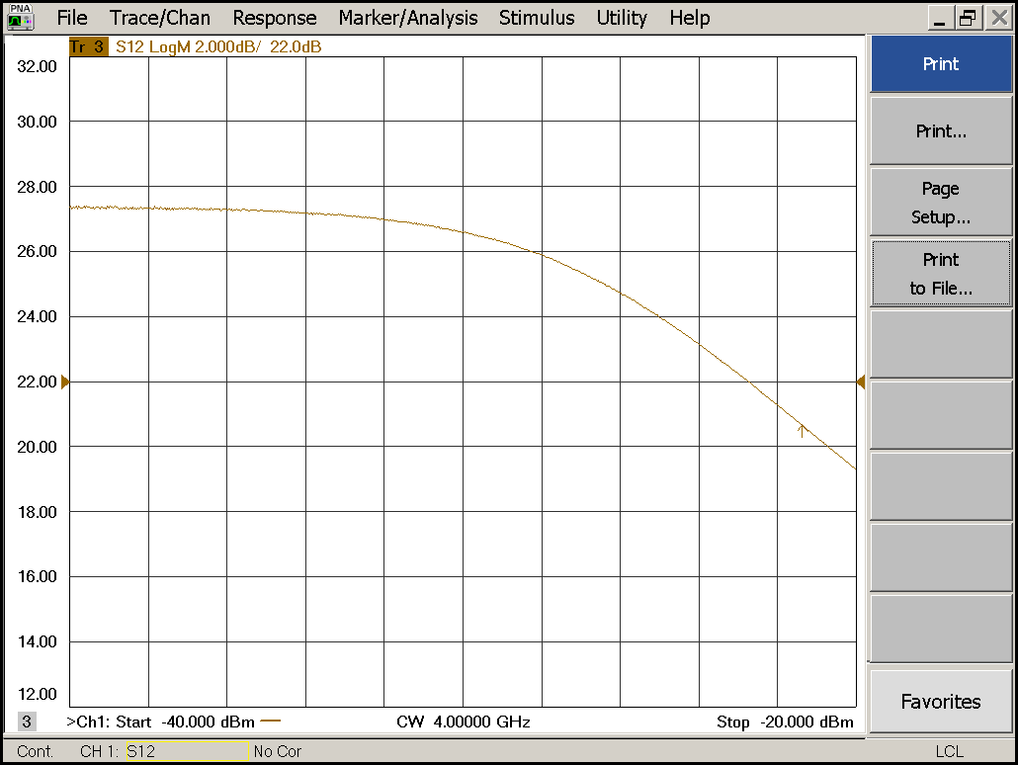

|  |  |  |  |
| --- | --- | --- | --- |
| Compression point: | OK 🗹 NOK 🗆 | Unwanted Features: | Yes 🗆 No 🗹 |

|  |
| --- |
| Y |

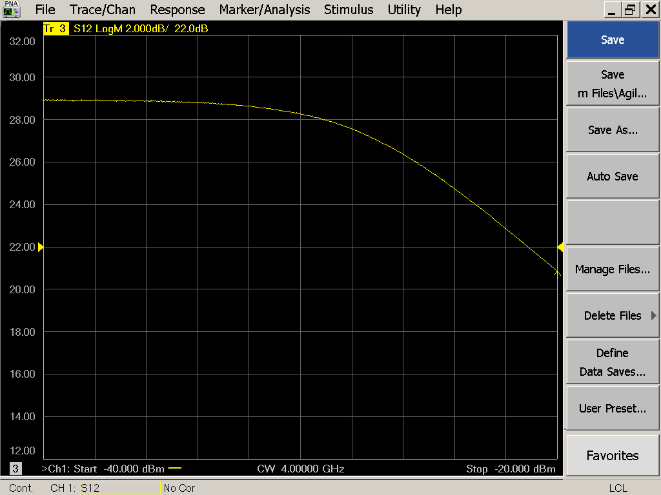

|  |  |  |  |
| --- | --- | --- | --- |
| Compression point: | OK 🗹 NOK 🗆 | Unwanted Features: | Yes 🗆 No 🗹 |

### Detector Calibration and Attenuator Sweep Pol X:

|  |  |  |
| --- | --- | --- |
| Load configuration: Detector_Calibration_PAX.csa | | |
| Freq : 4.0 GHz | Power Level: -20dBm | Sweep Time: -20sec |
| Sweep Mode: CW | Power Level at PAX Input (Measured): -40.6dBm | |

|  |  |  |  |  |
| --- | --- | --- | --- | --- |
| X | | | | |
| CW Input Power [dBm]: | Attenuator Value A [dB]: | Attenuator Value: B [dB]: | Detector Value: | Power Meter  Value [dBm]: |
| -40.6 | 0 | 0 | - | 13.4 |
| -40.6 | 0 | 3 | - | 13.2 |
| -40.6 | 0 | 6 | - | 12.1 |
| -40.6 | 0 | 9 | - | 9.7 |
| -40.6 | 0 | 12 | 0.8489 | 6.7 |
| -40.6 | 0 | 15 | 0.6617 | 3.9 |
| -40.6 | 0 | 18 | 0.3624 | 0.6 |
| -40.6 | 0 | 21 | 0.1998 | -2.5 |
| -40.6 | 3 | 21 | 0.0966 | -5.9 |
| -40.6 | 6 | 21 | 0.0504 | -9.0 |
| -40.6 | 9 | 21 | 0.0260 | -12.0 |
| -40.6 | 12 | 21 | 0.0136 | -14.9 |
| -40.6 | 15 | 21 | 0.0072 | -18.0 |
| -40.6 | 18 | 21 | 0.0038 | -21.2 |
| -40.6 | 21 | 21 | 0.0023 | -24.3 |
| -40.6 | 24 | 21 | 0.0016 | -27.1 |
| -40.6 | 27 | 21 | 0.0012 | -30.3 |
| -40.6 | 30 | 21 | 0.0010 | -33.4 |
| -40.6 | 30 | 24 | 0.0009 | -36.0 |
| -40.6 | 30 | 27 | 0.0009 | -38.5 |
| -40.6 | 30 | 30 | 0.0008 | -40.6 |

|  |  |  |
| --- | --- | --- |
| Use Noise Source: Atlantic AS6333 | | |
| Freq : 1.0 - 12.0GHz | Power Level: -41.8dBm |  |
| DC Supply: 28V |  | |

|  |  |  |  |  |
| --- | --- | --- | --- | --- |
| X | | | | |
| CW Input Power [dBm]: | Attenuator Value A [dB]: | Attenuator Value: B [dB]: | Detector Value: | Power Meter  Value [dBm]: |
| -41.8 | 0 | 0 | - | 11.6 |
| -41.8 | 0 | 3 | - | 10.4 |
| -41.8 | 0 | 6 | - | 8.6 |
| -41.8 | 0 | 9 | 0.8487 | 6.3 |
| -41.8 | 0 | 12 | 0.7825 | 3.6 |
| -41.8 | 0 | 15 | 0.4794 | 1.0 |
| -41.8 | 0 | 18 | 0.2525 | -2.2 |
| -41.8 | 0 | 21 | 0.1352 | -5.1 |
| -41.8 | 3 | 21 | 0.0682 | -8.2 |
| -41.8 | 6 | 21 | 0.0340 | -11.2 |
| -41.8 | 9 | 21 | 0.0178 | -14.1 |
| -41.8 | 12 | 21 | 0.0093 | -17.1 |
| -41.8 | 15 | 21 | 0.0054 | -19.8 |
| -41.8 | 18 | 21 | 0.0031 | -23.1 |
| -41.8 | 21 | 21 | 0.0020 | -26.2 |
| -41.8 | 24 | 21 | 0.0015 | -29.1 |
| -41.8 | 27 | 21 | 0.0012 | -31.9 |
| -41.8 | 30 | 21 | 0.0011 | -35.0 |
| -41.8 | 30 | 24 | 0.0010 | -37.5 |
| -41.8 | 30 | 27 | 0.0010 | -39.6 |
| -41.8 | 30 | 30 | 0.0010 | -41.5 |

### Detector Calibration and Attenuator Sweep Pol Y:

|  |  |  |
| --- | --- | --- |
| Load configuration: Detector_Calibration_PAX.csa | | |
| Freq : 4.0 GHz | Power Level: -20dBm | Sweep Time: -20sec |
| Sweep Mode: CW | Power Level at PAX Input (Measured): -40.6dBm | |

|  |  |  |  |  |
| --- | --- | --- | --- | --- |
| Y | | | | |
| CW Input Power [dBm]: | Attenuator Value A [dB]: | Attenuator Value: B [dB]: | Detector Value: | Power Meter  Value [dBm]: |
| -40.6 | 0 | 0 | - | 13.0 |
| -40.6 | 0 | 3 | - | 13.0 |
| -40.6 | 0 | 6 | - | 12.1 |
| -40.6 | 0 | 9 | - | 9.8 |
| -40.6 | 0 | 12 | - | 6.8 |
| -40.6 | 0 | 15 | 0.8473 | 4.0 |
| -40.6 | 0 | 18 | 0.5538 | 0.7 |
| -40.6 | 0 | 21 | 0.3158 | -2.3 |
| -40.6 | 3 | 21 | 0.1609 | -5.7 |
| -40.6 | 6 | 21 | 0.0853 | -8.7 |
| -40.6 | 9 | 21 | 0.0439 | -11.8 |
| -40.6 | 12 | 21 | 0.0230 | -14.8 |
| -40.6 | 15 | 21 | 0.0123 | -17.7 |
| -40.6 | 18 | 21 | 0.0064 | -21.0 |
| -40.6 | 21 | 21 | 0.0037 | -24.1 |
| -40.6 | 24 | 21 | 0.0025 | -26.9 |
| -40.6 | 27 | 21 | 0.0018 | -30.0 |
| -40.6 | 30 | 21 | 0.0015 | -33.1 |
| -40.6 | 30 | 24 | 0.0013 | -35.6 |
| -40.6 | 30 | 27 | 0.0013 | -38.1 |
| -40.6 | 30 | 30 | 0.0012 | -40.3 |

|  |  |  |
| --- | --- | --- |
| Use Noise Source: Atlantic AS6333 | | |
| Freq : 1.0 - 12.0GHz | Power Level: -41.8dBm |  |
| DC Supply: 28V |  | |

|  |  |  |  |  |
| --- | --- | --- | --- | --- |
| Y | | | | |
| CW Input Power [dBm]: | Attenuator Value A [dB]: | Attenuator Value: B [dB]: | Detector Value: | Power Meter  Value [dBm]: |
| -41.8 | 0 | 0 | - | 11.4 |
| -41.8 | 0 | 3 | - | 10.3 |
| -41.8 | 0 | 6 | - | 8.6 |
| -41.8 | 0 | 9 | - | 6.5 |
| -41.8 | 0 | 12 | 0.8470 | 3.7 |
| -41.8 | 0 | 15 | 0.8056 | 1.2 |
| -41.8 | 0 | 18 | 0.4395 | -2.1 |
| -41.8 | 0 | 21 | 0.2454 | -5.0 |
| -41.8 | 3 | 21 | 0.1300 | -7.9 |
| -41.8 | 6 | 21 | 0.0652 | -11.0 |
| -41.8 | 9 | 21 | 0.0337 | -13.9 |
| -41.8 | 12 | 21 | 0.0172 | -16.9 |
| -41.8 | 15 | 21 | 0.0099 | -19.6 |
| -41.8 | 18 | 21 | 0.0052 | -22.9 |
| -41.8 | 21 | 21 | 0.0033 | -26.0 |
| -41.8 | 24 | 21 | 0.0023 | -29.0 |
| -41.8 | 27 | 21 | 0.0018 | -31.6 |
| -41.8 | 30 | 21 | 0.0016 | -34.8 |
| -41.8 | 30 | 24 | 0.0014 | -37.3 |
| -41.8 | 30 | 27 | 0.0014 | -39.3 |
| -41.8 | 30 | 30 | 0.0013 | -41.3 |

# Inspection:

### Visual:

|  |  |  |
| --- | --- | --- |
| Fibre Connectors Clean | Comments: | OK 🗹 NOK 🗆 |
| Fibre Connector Mechanical | Comments: | OK **🗹** NOK **🗆** |
| RF Cable | Comments: | OK **🗹** NOK **🗆** |
| RF Connectors Clean | Comments: | OK **🗹** NOK **🗆** |

### Functions:

|  |  |  |
| --- | --- | --- |
| Read Temperature Value | Comments: 26.3 | OK 🗹 NOK 🗆 |
| LNA Settings | Comments: | OK**🗹** NOK **🗆** |
| Temperature Stabilisation | Comments: | OK 🗆 NOK **🗆** |
|  |  | OK 🗆 NOK **🗆** |